BULLY

#include<stdio.h>
#include<string.h>
#include<stdlib.h>
#define MAX 10
int list[MAX],n,c;
void display()
{
int i;
printf("\nProcesses-->");
for(i=1;i<=n;i++)
printf("\t %d",i);
printf("\nAlive-->");
for(i=1;i<=n;i++)
printf("\t %d",list[i]);
printf("\ncoordinator is::%d",c);
}
void bully()
{
int ch,crash,activate,i,gid,flag,subcdr;
do
{
printf("\n1.Crash\n2.Activate\n3.Display\n4.Exit\nEnter You choice::");
scanf("%d",&ch);
switch(ch)
{
case 1:
printf("\nEnter Process no. to Crash::");
scanf("%d",&crash);
if(list[crash])
list[crash]=0;
else
{
printf("\nProcess is alreaady dead!!");
break;
}
do
{
printf("\nEnter election generator id::");
scanf("%d",&gid);
if(gid==c)
{
printf("\nenter a valid generator id::");
}
}while(gid==crash);
flag=0;
if(crash==c)
{
for(i=gid+1;i<=n;i++)
{
printf("\nmessage is sent from %d to %d",gid,i);
if(list[i])
{
subcdr=i;
printf("Response is sent from %d to %d",i,gid);
flag=1;
}
}
if(flag==1)
{
c=subcdr;
}
else
{
c=gid;
}
}
display();
break;
case 2:
//activate
printf("\nEnter Process no. to Activated::");
scanf("%d",&activate);
if(!list[activate])
list[activate]=1;
else
{
printf("\nProcess is alreaady alive!!");
break;
}
if(activate==n)
{
c=n;
break;
}
for(i=activate+1;i<=n;i++)
{
printf("\nmessage is sent from %d to %d",activate,i);
if(list[i])
{
subcdr=i;
printf("Response is sent from %d to %d",i,activate);
flag=1;
}
}
if(flag==1)
{
c=subcdr;
}
else
{
c=activate;
}
display();
break;
case 3:
display();
break;
case 4:
break;
}
}while(ch!=4);
}
int main()
{
int i,j;
printf("\nEnter no. of process::");
scanf("%d",&n);
for(i=1;i<=n;i++)
{
printf("\nEnter Process %d is Alive or not(0/1)::",i);
scanf("%d",&list[i]);
if(list[i])
c=i;
}
display();
printf("\nBULLY ALGORITHM\n");
bully();
return 0;
}

OUTPUT
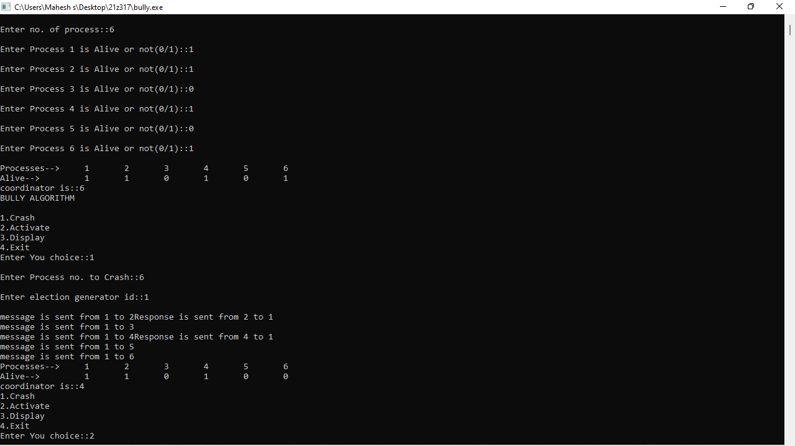

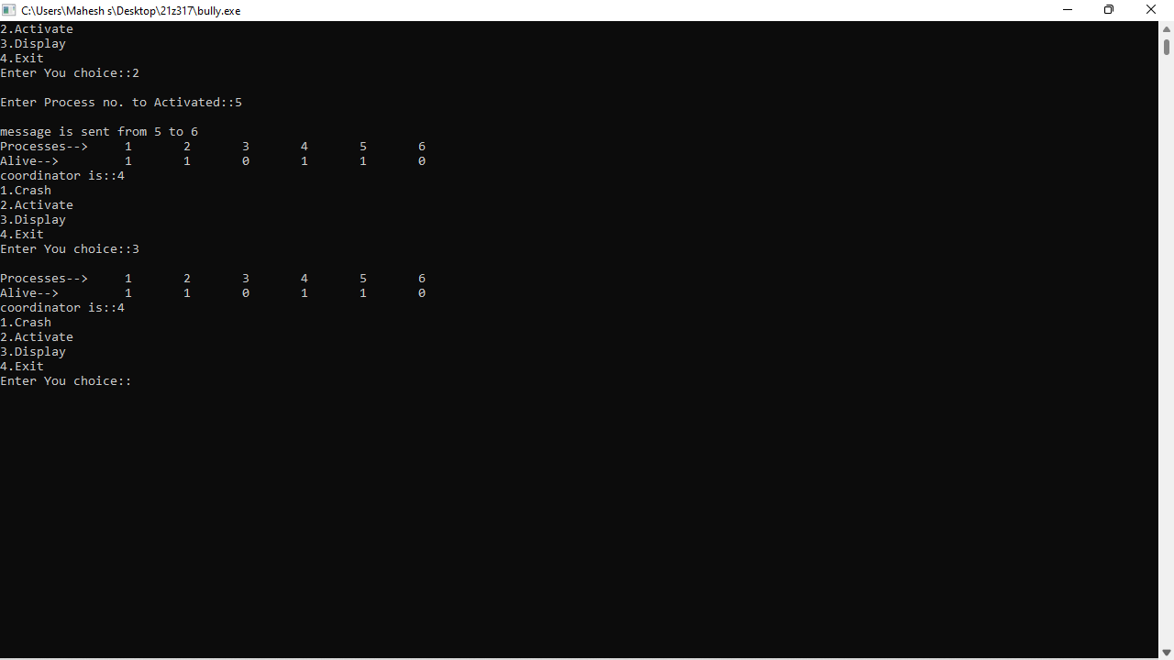
RING
#include<stdio.h>
#include<string.h>
#include<stdlib.h>
#define MAX 10
int list[MAX],n,c;
void display()
{
int i;
printf("\nProcesses-->");
for(i=1;i<=n;i++)
printf("\t %d",i);
printf("\nAlive-->");
for(i=1;i<=n;i++)
printf("\t %d",list[i]);
printf("\ncoordinator is::%d",c);
}
void ring()
{
int msg[20],ring_n,k,i;
int ch,crash,activate,gid,flag,subcdr;
do
{
printf("\n1.Crash\n2.Activate\n3.Display\n4.Exit\nEnter You choice::");
scanf("%d",&ch);
switch(ch)
{
case 1:
printf("\nEnter Process no. to Crash::");
scanf("%d",&crash);
if(list[crash])
list[crash]=0;
else
{
printf("\nProcess is alreaady dead!!");
break;
}
do
{
printf("\nEnter election generator id::");
scanf("%d",&gid);
if(gid==c)
{
printf("\nenter a valid generator id::");
}
}while(gid==crash);
flag=0;
k=1;
if(crash==c)
{
msg[k++]=gid;
for(i=(gid+1)%n;i!=gid;i=(i+1)%n)
{
if(list[i])
{
printf("\nmessage is sent to %d k =%d",i,k);
msg[k++]=i;
// printf("Response is sent from %d to %d",i,gid);

}
}
subcdr=0;
for(i=1;i<k;i++)
{
printf("\nmsg::%d\n",msg[i]);
if(subcdr<msg[i])
{
subcdr=msg[i];
}
}
c=subcdr;
}
display();
break;
case 2:
//activate
printf("\nEnter Process no. to Activated::");
scanf("%d",&activate);
if(!list[activate])
list[activate]=1;
else
{
printf("\nProcess is alreaady alive!!");
break;
}
//
if(activate==n)
{
c=n;
break;
}
for(i=activate+1;i<=n;i++)
{
printf("\nmessage is sent from %d to %d",activate,i);
if(list[i])
{
subcdr=i;
printf("\nResponse is sent from %d to %d",i,activate);
flag=1;
}
}
if(flag==1)
{
c=subcdr;
}
else
{
c=activate;
}

display();
break;
case 3:
display();
break;
case 4:
break;
}
}while(ch!=4);

}
int main()
{
int i,j;
printf("\nEnter no. of process::");
scanf("%d",&n);
for(i=1;i<=n;i++)
{
printf("\nEnter Process %d is Alive or not(0/1)::",i);
scanf("%d",&list[i]);
if(list[i])
c=i;
}
display();
printf("\nRING ALGORITHM\n");
ring();
return 0;
}

